File Cabinet:
For every file in Practice, there should be a correlating file in File Cabinet.
File Cabinet functions as a physical file cabinet would, it will hold any and all client documents
EX: Tax returns, back up docs, routing sheets, signed agreements and e file forms, payroll, bookkeeping Financial statements, Card authorizations. 1099, sales tax, any IRS or FTB notices.
*Utilize the notes section of the file cabinet:
Contact info: phone numbers, emails, portal log in
Full portal, hybrid portal, non-portal
Client requests
Date of death for deceased clients
Address changes
Any client complaints or if client is difficult.
Bookkeeping notes
*All notes in File Cabinet are Internal notes only
Active client:
Inactive client:
*Do not save documents locked with a password- see “Printing to File Cabinet” to print opened documents to file cabinet.

Printing from File Cabinet

To Print A single page from file cabinet:
Select the Printer image with “1” on front

This will print only the page that is previewed in file cabinet.

To Print Multiple pages from File Cabinet:
Select Printer Image

Print screen will show:
- Select files to print from column on the left
- Click “Select” to move the right Column,
- Click “Print”
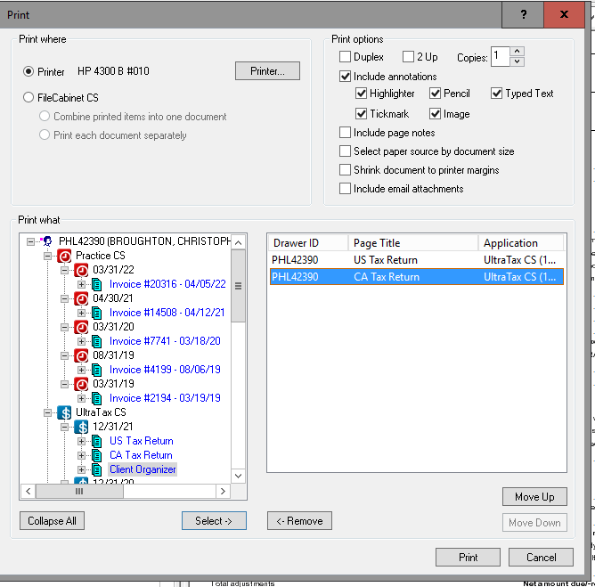

Printing to File Cabinet:
You can either print form portal or from a PDF, or excel
*Printing from RHW Portal:
*Log in to RHW portal, search client
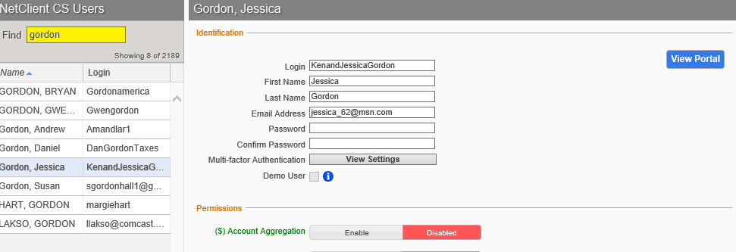
- Select “View Portal”
- Select “ File Exchange” 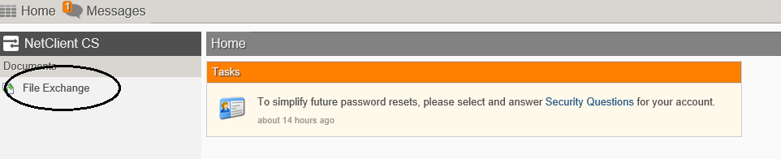
- Select “ Documents to RHW” ( sometimes clients will put documents in “Actionable Items form RHW, if you can not find it in Documents to RHW, Check the actionable folder)

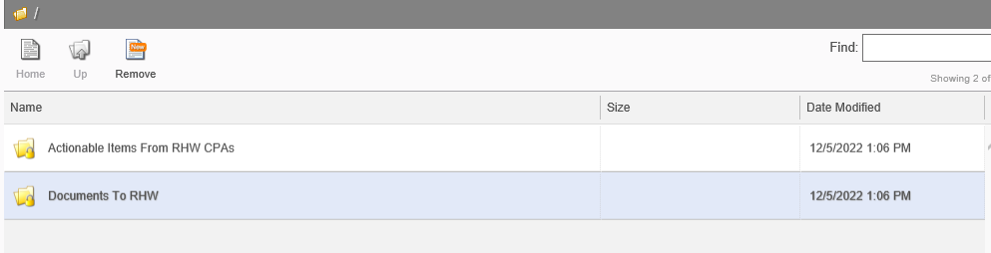

- Open the document you want to print, this will open the document as a PDF
- Select the Print symbol
- Select “FileCabinet CS” as the printer

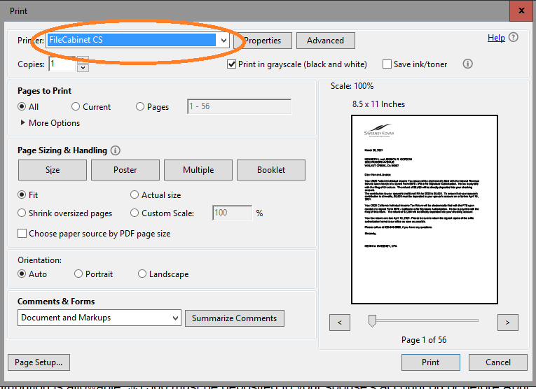

- This will open a new File Cabinet window
- Search client ID number,
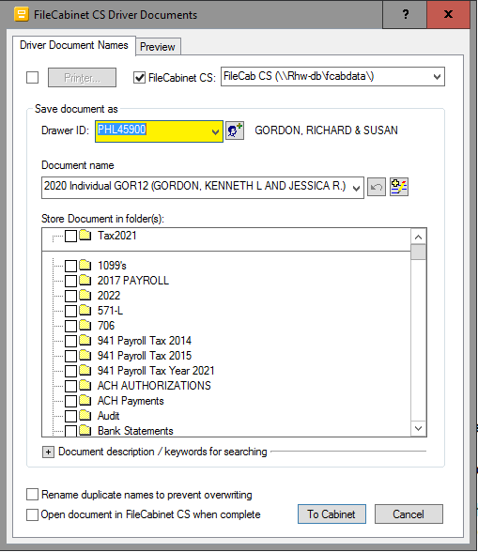

- Select which file to attach document to
IE: Tax2021, notices, ACH, Bank statements
- Rename, if needed. Client name and basic description.
- Select “To Cabinet”
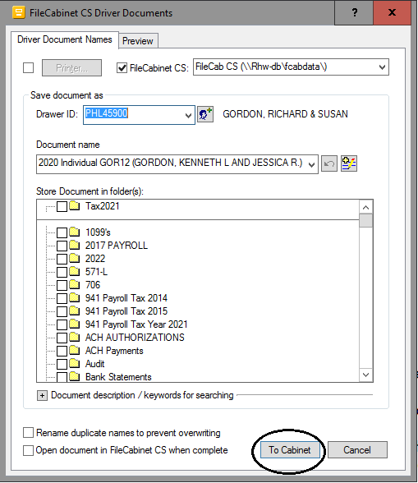

- Once the document is printed to File Cabinet, the window will close.
Printing to File Cabinet from a PDF:
- Open Selected PDF documents
- Chose the print Icon from the heading

- Select “FileCabinet CS” as the printer

- This will open a new File Cabinet window
Search client ID number


- Select which file to attach document to
IE: Tax2021, notices, ACH, Bank statements
- Rename, if needed. Client name and basic description.
- Select “To Cabinet”


Printing from Excel:
- Open desired Excel sheet
- Select “File”
- Chose “Print”
- Select “FileCabinet CS “ as printer
  - SETTINGS;
    - Print Entire Work Book
    - Landscape Orientation
    - Narrow Margins
    - Scaling: chose best option
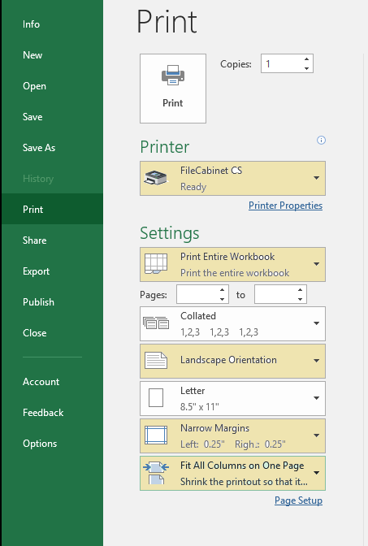
- Click “Print”
- This will open a new File Cabinet window
Search client ID number


- Select which file to attach document to
IE: Tax2021, notices, ACH, Bank statements
- Rename, if needed. Client name and basic description.
- Select “To Cabinet”

Creating PDF from File Cabinet:

*Search Client:
Expand Client folder
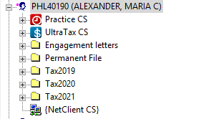
Printing tax returns:
Expand “Ultra TX CS
- Select tax year
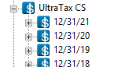
- Expand chosen tax year
- 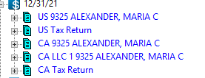

Select the envelope at the top options :
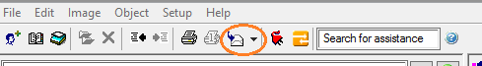
- there will be two drop down options
  - Email Recipient
  - File
Select “File”
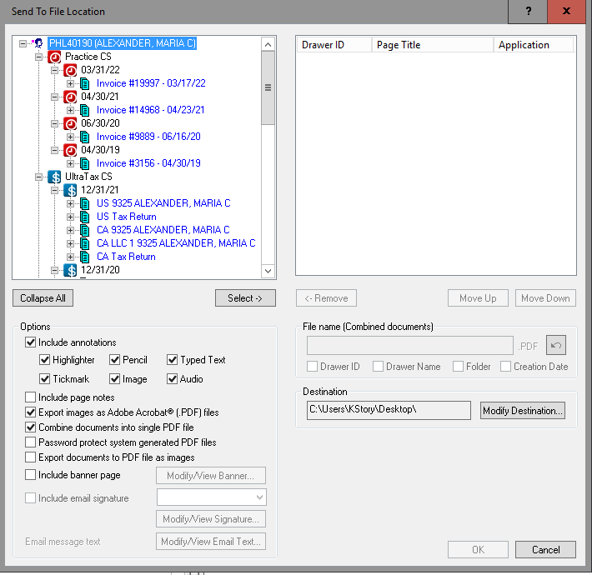

Select Which returns you want to print, and click “Select” to move to the right Column
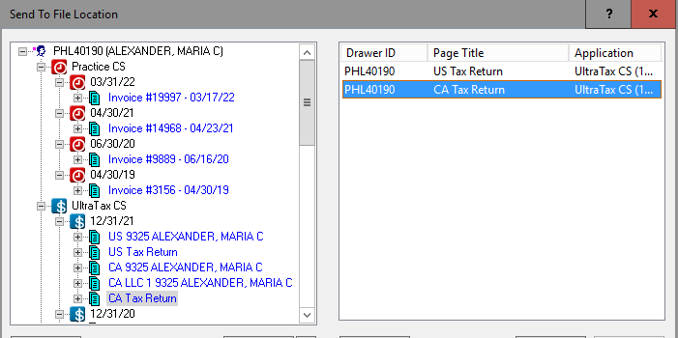
*For printing and emailing a return to client, you will need to Password protect the returns
Select “Password Project System generated PDF Files”*
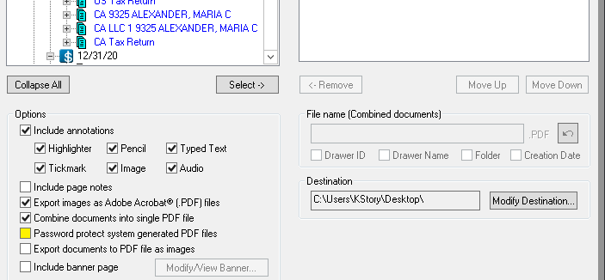

Use the last four of the client’s Social Security Number as the password
*This can be found on the tax returns Form 1040 Page 1*
Check that “Combine Documents into single PDF Files
Export Images as Adobe Acrobat are check as well
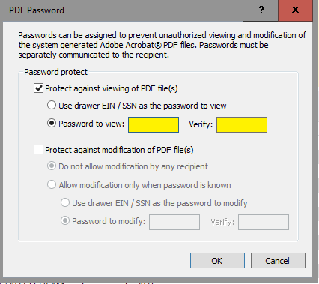
Click “OK”

Rename file name:
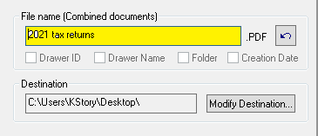
Returns are now ready to email to client.
Create new email
Move attachment to email.
Emailing client:
Good afternoon John Smith.
Attached are your 2021 tax returns that you requested.
The password is the last four of your Social Security Number, or SSN
Please contact us if you have any other questions.
Thank you
Kristen Story.

Sending Documents to Portal:
- Step 1: Select Client
- Step 2: Expand folder
- Step 3: chose folder from which requested documents are in
  - Ultra-tax for taxes, Financial statements for Balance sheets and Profit and Loss, Payroll by year,
- Step 4: Drag and drop chose file to “{NetClient CS} and Chose “Copy Here”
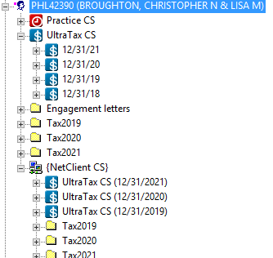

- Step 5 : chose the RED PLUG at the top of the screen
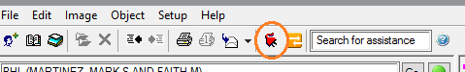

- Step 6: Check box “Transmit to NetClient CS”
  - Be sure to uncheck “Retrieve available updates”
Click “Select Drawers”
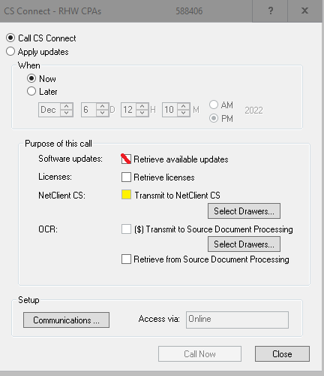
- Step 7: Click “Select ” this will move the last searched file to the right column,
Reminder to remove the un-needed files from the right column.
*Note: you can add multiple files to send to the portal in batches
Click “OK”

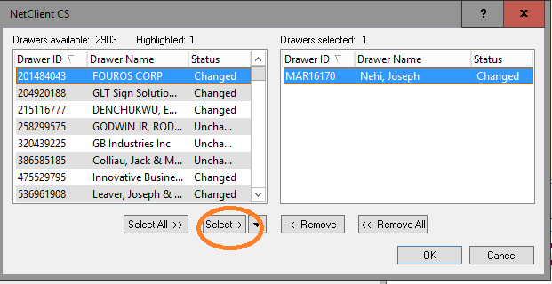
- Step 8: Click “Call Now


This will send the chosen documents to the portal.
The RHW email will receive a notice of any uploaded documents
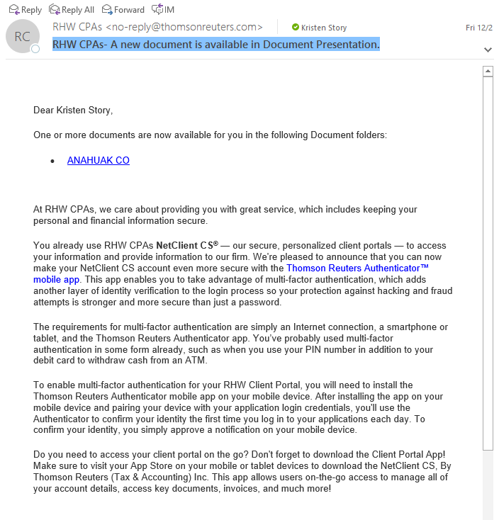

Linking File Cabinet to portal :
Step one: Search for client, either by last name or Client ID number
Step two: Right click to bring up a drop down box,
Select : “Drawer Properties”
Add client Email that was used to set up the portal
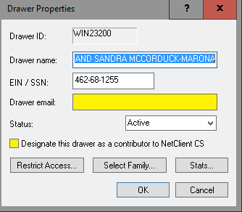
Step Three: Click “OK”
This will add {NetClient CS} to the bottom of the file list for the client
Step Four : From the top bar chose the RED Plug
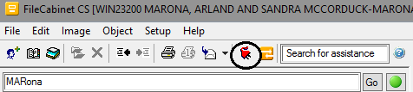
Step Five: UNCHECK “Retrieve available updates”
Check “Transmit to NetClient CS”
Click on “Select Drawers”


Step Six: Click “Select” this will move the last searched file to the right column,
Reminder to remove the un-needed files from the right column.
*Note: you can add multiple files to send to the portal in batches
Click “OK”
Step Seven: Click “ Call Now”
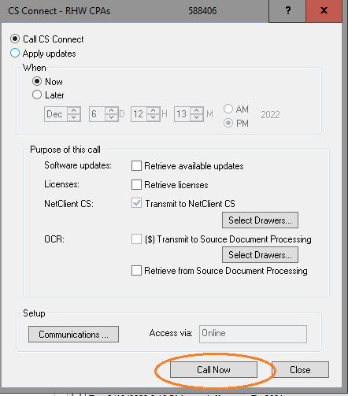

This will allow for the client file to populate when assigning to the portal.

